RESOLUTION NO.__________

RE: CERTIFICATE OF APPROPRIATENESS UNDER THE

PROVISIONS OF THE ACT OF THE PENNSYLVANIA

LEGISLATURE 1961, JUNE 13, P.L. 282 (53

SECTION 8004) AND BETHLEHEM ORDINANCE NO.

3952 AS AMENDED.

WHEREAS, it is proposed to install banners at 127 E 4th Street.

NOW, THEREFORE, BE IT RESOLVED by the Council of the City of Bethlehem that a Certificate of Appropriateness is hereby granted for the work.

Sponsored by: (s)

(s)

ADOPTED BY COUNCIL THIS DAY OF

(s)

President of Council

ATTEST:

(s)

City Clerk

HISTORIC CONSERVATION COMMISSION

CASE # 591– It is proposed to install banners at 127 E 4th Street

OWNER/APPLICANT: Holy Infancy R. C. Church / Joseph McCarthy

The Commission upon motion by Mr. Evans seconded by Mr. Cornish adopted the proposal that City Council issue a Certificate of Appropriateness for the proposed work described herein:

1. The proposal to install banners roof at 127 E 4th Street was presented by Joe McCarthy.
2. Two banners, 4’ x 10’ in size, will be installed on each side of the main entrance to the school. The banners will have the same design, but one will be in English and the other in Spanish.
3. The banners will have an ivory background with a pinstripe border and have ventilation flaps. The pinstripe should be approximately 1/2” in thickness and located 1 1/2” to 2” from the edge. The pinstripe color should blend with the other colors used on the banner.
4. The mounting hardware for the banners will be attached into mortar joints, and the attachment detail should be engineered for safety.
5. The banner material may be either a vinyl coated fabric or the regularly approved canvas fabric Sunbrella or equal.
6. The motion was unanimously approved.

CU: cu

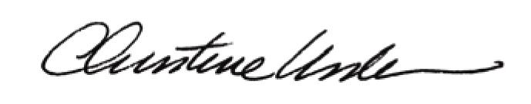

By:

Date of Meeting: June 20, 2016 Title: Historic Officer